**JS MILESTONE 1**

● History of JS

● ECMA Script

● How Javascript and ECMA are related.

● DOM and Browser Object Model

Scripting language – instructions/ code written to view output in real time. Source code is translated in real time after execution.

JS – Scripting language used to bring functionalities.

JS Engine – executes JS code and displays output in browser. (V8, Spider Monkey).

Common use of JavaScript is to dynamically modify HTML and CSS to update a user interface, via the Document Object Model API

1. History of JS:

* 1st widely used web browser 🡪 Mosaic web browser.
* Mosaic web browser was written by Marc Andreessen, part-time employee of NCSA at University of Illinois.
* After graduation in 1993, he moved to California and met Jim Clark (founder of Silicon Graphics)
* They started a company named “MOSAIC COMMUNICATIONS CORPORATIONS”
* As University of Illinois is unhappy with the name ‘mosaic’ they’ve changed it to “NETSCAPE COMMUNICATIONS”.
* In 1994, they launched **Netscape navigator** web browser.
* But in 1995, Microsoft came into competition by launching **Internet Explorer.**
* With windowsOS IE was given in free of cost, but Netscape navigator was a paid version. So it pushed Netscape to innovate new things.
* At that time, websites were mostly static and slow. If a form is to be filled on websites, validation for input fields had to be done through a full round trip to the server. This may also result in data loss.
* So this process required small scripting language, that is available for both software engineers (server side) and also for people (client side) with more programming experience.
* To overcome this issue and to outdo Microsoft’s IE, Netscape collaborated with Sun microsystems. The Sun microsystem was developing Java programming language.
* In 1995, Netscape hired Brendan Eich to develop and introduce a new scripting language for the browsers.
* Within 10 days Eich created a prototype and named it **“MOCHA”.**
* Mocha consists of first-class functions (treating functions as variables) combined syntax of Java, Object orientation of Self etc.,
* Mocha was renamed to 🡪 Livescript, then to gain popularity it was again renamed to Javascript.
* This was the time, there was intense competition among web browser vendors in the market.

1. ECMAScript

* Other vendors, reverse engineered JS (as it is an open-source tool), and released it in different names.
* Microsoft done the same thing, named the language as JScript.
* When Netscape Navigator 3 was launched, Microsoft launched its new version of IE as IE3 which had an implementation of JScript.
* So there were 2 versions of Javascript with different names.
* This became a bother for developers, as the code worked perfectly in one browser and was useless in another browser.
* To avoid this conflict, in 1997, Netscape approached ECMA (European Computer Manufacturers Association) and asked them to standardize Javascript.
* ECMA is a company doing standardizations.
* The ECMA committee created a standard known a ECMA-262, which is a defined new scripting language called ECMAScript.
* This ECMAScript is adopted by all the web browsers.
* ECMAScript defines the core standards for JavaScript, ensuring that different implementations of JavaScript adhere to common rules and features.
* The first edition, ECMAScript 1, resolved many of the issues with cross-browser compatibility and introduced a common set of features that modern JavaScript is built upon.

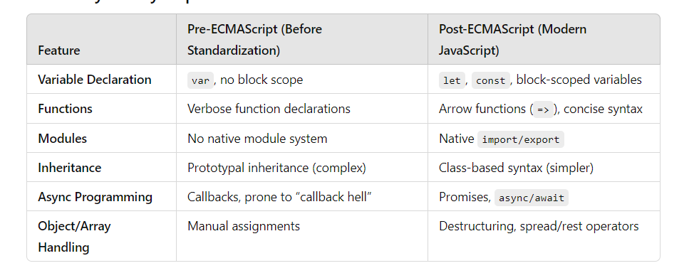

* In 1998, 1999 ECMAScript2 and ECMAScript3 versions were released.
* 2nd version of ECMA was released to fix inconsistencies between ECMA and ISO standards for JS.
* ES3 remained supported for many browsers for many years.
* So ES3 remained foundation for many libraries even after release of later versions of standard.
* ES4 and ES5 faced some problems. As ideas discussed for ES4 was too complex, it has not been released
* Then ES5 have been released in Dec 2009. It became fully supported in 2014.
* ECMAScript 2015 and further
  + It took 7 years to release EC5 to EC6 🡪 named as Harmony then changed to ECMA2015.

1. How JS and ECMAScript is related?

* ECMAScript – standard for scripting languages.
* JS – Follows ECMAScript according to standards to ensure JS executes perfectly in all browsers.

1. DOM and Browser Object Model

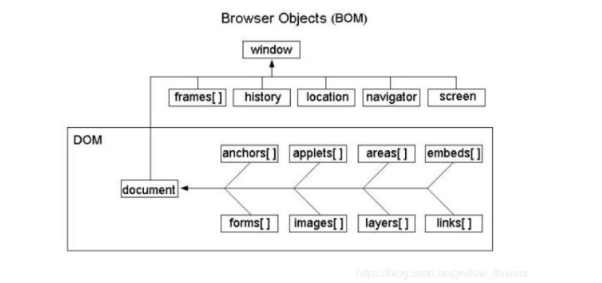

* DOM: The document object represents the whole html document. When html document is loaded in the browser, it becomes a document object.
* BOM: The window object represents a window in browser. An object of window is created automatically by the browser.
  + DOM – complete JS representation(object) of the HTML document.
  + BOM – additional objects provided by the browser for working, except with the document.
* DOM focuses on the structure and content of web documents
* The BOM deals with browser specific features and behavior.
* Behaviour of browser, managing cookies, interacting with frames, handling events can be done by using BOM.
* BOM includes objects like window, screen, location, history, navigator.
* Content, structure, style of a web page using JS can be manipulated using DOM.